using System;

namespace CP_Lab_07
{
class Program
{
static void Main(string[] args)
{
// for (int i = 4; i > 0; i--)
// {
// for (int j = 0; j < i; j++)
// {
// Console.Write("{0} ", i + j);
// }
// Console.WriteLine("");
// }

// Console.Write("n = ");
// int n = int.Parse(Console.ReadLine());
// int num = 1;
// int sum = 1;
// Console.Write("The sum 1");
// while (num < n)
// {
// num++;
// sum += num;
// Console.Write("+" + num);
// }
// Console.WriteLine("=" + sum);

// Console.Write("n = ");
// int n = int.Parse(Console.ReadLine());
// int num = 1;
// int sum = 1;
// Console.Write("{0}! is", n);
// while (num < n)
// {
// num++;
// sum *= num;
// Console.Write("*" + num);
// }
// Console.WriteLine("=" + sum);

//Console.Write("n = ");
//int n = int.Parse(Console.ReadLine());
//decimal factorial = 1;
//do
//{
// factorial *= n;
// n--;
//} while (n > 0);
//Console.WriteLine("n! =" + factorial);

//Console.Write("n = ");
//int n = int.Parse(Console.ReadLine());
//int a = 0;
//int b = 1;
//int c = 0;
//Console.Write("The Series is 0,1,");
//while (n > 0)
//{
// c = a + b;
// Console.Write(c + ",");
// a = b;
// b = c;
// n--;
//}

//int n = 1;
//while (n <51)
//{
// double root = Math.Sqrt(n);
// Console.WriteLine("The Square Root of {0} is {1}", n, root);
// n += 2;
//}
}
}
}

Task No 01:
Input:
Console.Write("n = ");
int n = int.Parse(Console.ReadLine());
int a = 0;
int b = 1;
int c = 0;
Console.Write("The Series is 0,1,");
while (n > 0)
{
c = a + b;
Console.Write(c + ",");
a = b;
b = c;
n--;
}
Output:
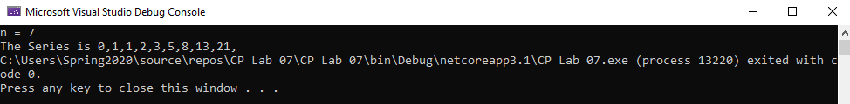

Task No 02:
Input:

Output:

Task No 03:
Input:
int n = 1;
while (n <51)
{
double root = Math.Sqrt(n);
Console.WriteLine("The Square Root of {0} is {1}", n, root);
n += 2;
}
Output:
